**Keep Reading!**

**Home Learning Pack – April 2020**

**Introduction for families**

We recognise that for many parents and carers the task of providing appropriate educational experiences for your children can be daunting but we want to reassure you that the most valuable thing you can do for your child is to keep reading. Not only is this highly beneficial, whatever age they are but now more than ever, it will provide important quality family bonding time and help you to positively influence your children’s future attitudes toward reading. Sharing books with your children is a great way to build their confidence and competence as readers. To help you, we have put together a range of suggestions for home learning that are designed to keep you and your children enjoying reading together. Some activities that are designed to be short and will require minimum input whereas others will need a little more support from an adult.

**Top tips:**

* There are lots of resources out there and it is easy to get swamped. Pick just a few and go with those, otherwise you can spend a lot of time just looking at websites.
* Some websites have great resources, but they can be complicated and are perhaps best for teachers. In this guide, we have selected some that are particularly good for parents and some that children can access without you, in case you need a 5-minute break!
* You could try to plan in one or two reading activities a day; routine is very important to children and this will help to structure your day. Daily online phonics sessions are available as well as daily storytelling sessions (see details below). Try to plan one activity just sharing and reading a book together or listening to a story from one of the websites listed and another could be a planned activity from the list in this guide.
* Let them choose what they would like to read, they will feel more interested in the story if they’ve picked it out themselves. Don’t worry if they keep returning to the same story or the same author, repetition and familiarity is highly beneficial for young readers.
* Snuggle up and sit close together, encourage your child to hold the book themselves and turn the pages too if they like.
* Take a look at the pictures. You don’t have to just read the words on the page. Maybe there is something funny in the pictures that you can giggle about together, or perhaps your child enjoys guessing what will happen next.

**Read to your child**

* Hearing stories, helps brain development, concentration, social skills, well-being, creativity, vocabulary and most importantly means bonding time with you.
* Children love an adult reading to them; we want them to be readers for life and this is the key to this.
* Read for **enjoyment** and **pleasure**; talk to them about your favourite stories and share a bedtime story whenever you can.
* Add sound effects when reading a story and encourage your child to join with different voices and say the rhyming words or end of sentences/repeated phrases.

Most importantly, have fun and enjoy the time you have together. We wish you every success and look forward to hearing from you as you try some of these activities.

If you would like any help, please do send a note to [**englishhub@roadeprimary.org**](mailto:englishhub@roadeprimary.org) and we will be very happy to support.

**Contents: Page**

Introduction and Top Tips 1

Fun Reading Activities 3 - 4

Phonics 5 - 12

Reading for Pleasure 13 - 14

Vocabulary and Language Development 14 - 16

**Fun Reading Activities**

**The British Library** - <https://www.britishcouncil.org/school-resources/find>

Image credit: Sketches for *The Gruffalo,* 1999 © Axel Scheffler 1999. Photo by Joseph Turp

The British Library has just launched a brand new website – [**Discovering Children’s Books**](https://www.bl.uk/childrens-books/). It is completely free to access and full of creative activities to do at home. Aimed at primary school children, teachers and book-lovers of all ages, the site explores the history and rich variety of children’s literature, through treasures from the British Library. Go down the rabbit hole with **Lewis Carroll’s** original manuscript of *Alice’s Adventures in Wonderland*. Rifle through **Roald Dahl’s** drafts, **John Agard’s** poetry notebooks or sketches by **Judith Kerr**, **Axel Scheffler** and **Liz Pichon**. For the writers and artists of the future, there is a gallery of free [activities](https://www.bl.uk/childrens-books/creative-activities) to spark children’s creativity and inspire their own stories, poems, illustrations and more.

* **Learn how to draw a Gruffalo**

<https://www.bl.uk/childrens-books/videos/axel-scheffler-how-to-draw-a-gruffalo>

* **Create your own characters**

[https://www.bl.uk/childrens-books/videos/viviane-schwarz-how-to-develop-a-character#](https://www.bl.uk/childrens-books/videos/viviane-schwarz-how-to-develop-a-character)

* **Try Joseph Coehlo’s poetry prompts**

<https://www.bl.uk/childrens-books/activities/poetry-prompts>

* **Make a miniature book**

<https://www.bl.uk/childrens-books/activities/make-a-miniature-book>

* **Make your own comic strips**

<https://www.bl.uk/childrens-books/activities/make-your-own-comic-strip-stories>

* **Invent your own superhero**

<https://www.bl.uk/childrens-books/activities/what-makes-a-hero-super>

* **Favourite Facetime Read** – set a special time each day for a special person to Facetime you to read the children a story. This could be a favourite uncle or cousin, or a grandparent. They could read their favourite stories from when they were a child and talk about why they loved them.
* **Reading Rainbow** – this is a new take on the ‘Reading River’ with a rainbow theme. If your child has already created a rainbow and displayed it in the window, they could go one step further and add all the things they have read over the last week. This could include books, magazines, signs, posters or packaging**.**
* **Book Nook** – make a special place in your house or garden that you and your children can read together, let them be creative and design it just as they want it.
* **Treasure Hunt** – send your children on a treasure hunt, the treasure being a good book! Leave clues that lead them around the house to discover it in an unexpected place. If you are really into it, the clues could relate to the story. The magic of discovering a [**book**](https://www.todaysparent.com/tag/books) at the end of the hunt will show your kids how valuable they can be.
* **Get Caught Reading** – challenge your children and other members of the family to find the most extreme and obscure place to read their favourite book. Take a snap and make a display. There could be a prize for the craziest place!
* **The Storytime Jar** – decorate a jar and label it for a bit of magic. Ask your children to write down the names of their three favourite books on a piece of paper and place it in the jar. Take turns to pick a story from the jar to read each day.
* **The Walking Read** – on your daily walk, challenge your children to find and read as many signs and labels as they can. Have they learnt any new words?
* **All Wrapped Up** – pick a new book they have not read or one they have not read for a while and wrap it up. Play pass the parcel with the family whist you open the book and challenge them to guess what the book might be about each time they tear a layer of wrapping off.
* **The Chocolate Read** – a good Friday reading activity – use this time to snuggle up together with your favourite book and nibble on some chocolate!

**Fun with Phonics**

* **Ruth Miskin** is delivering a daily **Read, Write Inc.** (RWI) phonics sessions at <https://www.ruthmiskin.com/en/>
* **Twinkl** is delivering a daily phonics lesson, 9.30 to 10.30 a.m. Go on to the website and click on the Home Learning Hub. <https://www.twinkl.com/>
* **Phonics Play** - <https://www.phonicsplay.co.uk/> - a useful website featuring free resources for KS1.

***Letters and Sounds Phonics Parent Guide***

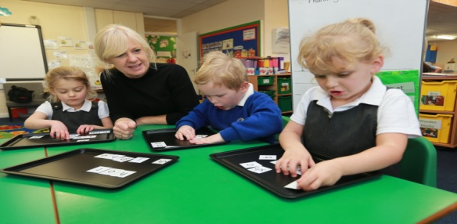

**Introduction**

The ability to read is a crucial life skill and a key priority for early learning, not only to ensure success in education, but confidence, well-being and above all ensure life chances. Love of reading is important, so children enjoy reading and become lifelong readers. High quality systematic phonics is a prime tool by which we use to teach children how to read and spell words.

This guidance has been written to give parents a brief overview of letters and sounds, phonic key principles and ways to support at home.

**What is Phonics?**

* Hearing and identifying spoken sounds in words.
* Phonics involves the process of hearing, saying, and reading letters (graphemes) which represent sounds (phonemes).
* Children sound out or **blend** to read (decode) words.
* Children **segment** by hearing a sound and writing a letter to represent that sound (encoding).

**What is Letters and Sounds?**

Letters and Sounds is a structured teaching programme of guidance to aid the teaching of Phonics for reading, which is used by teachers across England in primary schools.

A set order is followed to allow greater access to word blending and reading in texts.

For example, **s a t p i n** can make: at as sat tap pin nip, etc whereas **a b c d e....** is limited.

Furthermore, words need a vowel, so the order of phonemes is carefully structured to springboard children into reading more efficiently.

*The sequence of hear it, see it, read it and write it is used alongside the continuation of ‘say the sound.’*

**Decodable books**

Strong emphasize is placed upon the reading of books using the ‘code’ or sounds taught so far. Children should not be expected to read books containing ‘code’ or ‘phonemes’ which they have not yet been taught. Alongside practising blending to read sounds (decode), it is

important children are exposed to different types of books and have stories read to the, to develop their comprehension (understanding) vocabulary, social, listening skills and vocabulary.

The content is organised into 6 phases and is organised to best meet individual children’s needs and interests to make it fun and engaging.

*Letters and Sounds is based on the principles of high quality teaching and learning.*

**Children will learn to:**

***Phase One (Nursery / Foundation Stage)***

*tune into sound awareness and discriminate speech sounds, through talk and attentive listening;*

*sing and recite rhymes and songs;*

*oral blend to explore and play with sounds;*

***Phase Two (Foundation Stage/Reception)***

*single sounds and most common digraphs to blend simple (3 letter) words;*

**s a t p i m n d g o c k**

**ck e u r h b f ff l ll s**

***Phase Three (Reception)***

*read and write the most common sounds for blending (sounding out) to read longer words*

*segmenting (split) words for spelling;*

**j v w x y z, zz qu**

**ch** chip **sh** shop **th** thick/then  **ng** sing

**ai** rain **oa** boat **igh** night **ee** feet **or** for **ar** farm

**oo** boot/look **oi-** soil  **ur** hurt **ow** cow **air** fair

**ear** dear **ure**-pure **er** corner

***Phase 4 (Reception)***

*blending adjacent consonants, i****.e. b + r + u + sh= brush.***

*read and spell tricky words;*

*apply the skill of blending to read unfamiliar texts.*

***Phase 5 (Year One)***

*read the advanced code where children investigate how sounds can be represented by different spellings****: ai, ay a-e paint, day, cake;***

*read and write long vowels phonemes: ai ee ir oa oo.*

**ay** day **oy** toy **wh** when **a-e** cake

**ou** out **ir** girl **ph** photo **e-e** these

**ie** tie **ue** blue **ew** new **i-e** like

**ea** eat **aw** paw **oe** toe **o-e** home

**au** Paul **u-e** rule

***Phase 6 (Year Two)***

*apply more accurate spelling choices as now children have been taught all the ways to make ‘ie’ (igh i-e _y).*

*spell prefixes- un, dis and suffixes such as er, est, ed and ing.*

*grammar past and present tense,* ***i.e today I am skipping, yesterday I skipped.***

*spell irregular spellings and learn less common spellings, such as* ***ch- chin, school, chef.***

***Glossary***

**Phoneme (sound)**is the smallest unit of sound in a word. 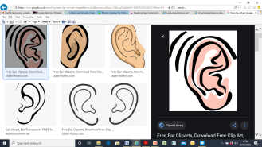

***c-oa-t= coat***

**Letter(s) or grapheme** represents a phoneme: ***a, k, oi, dge***

**Digraph**

Two letters, one sound: ***ai ee ie oa oo***

**Trigraph**

**T**hree letter, one phoneme:***dge, igh, air***

**Split digraph**

A digraph in which the two letters are split: ***a-e as in cake***

**Consonant digraphs: *ch sh th* *ng***

**Vowel digraphs: *ai ee oa* ar (has at least one vowel)**

**CVC**

**Consonant, vowel consonant: cat, road**

**Stretchy sounds** (long sounds mmmmmm....)

***m n s f l r v sh th ng***

**Bouncy sounds** (hard and short ‘b’’b’’b’**)**

***b d c c k x p ch***

**Top tips:**

* Try not to add an ‘uh’ after the sound. Nnnnn... not nnnuh.’
* Let children see your mouth shape and tongue position as you softly say a

sound.

* Some sounds are spelled in different ways: ai, ay, a-e; same sound but different spelling.
* Some sounds are pronounced in different ways: ow- show ow- town;

same spelling but different sound.

***Oral blending*** 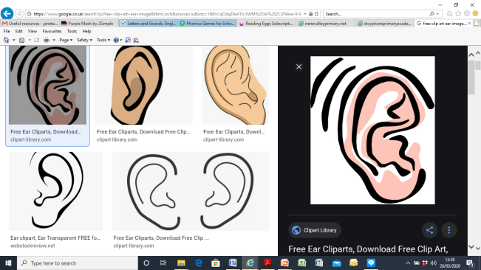

Hearing spoken sounds and pushing **(blending)** them together to make a spoken word – **no word cards are used. It is listening and saying the sounds.**

**Talk like a robot:** 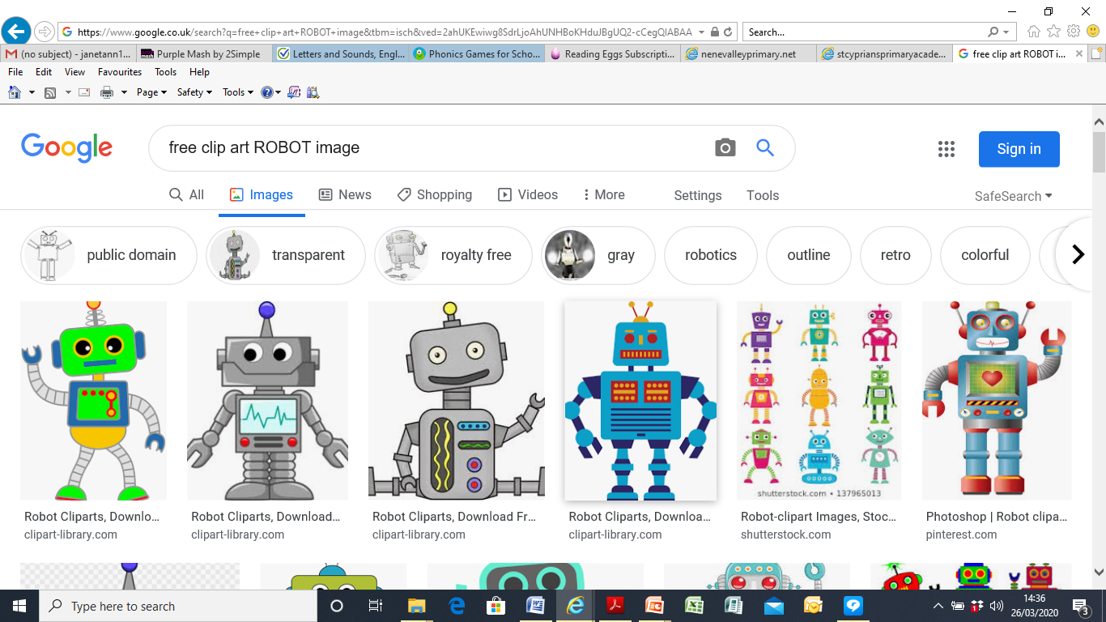

*Adult says ‘****p-o-t****’, the children say ‘pot’.*

***Blending ***

Pushing sounds (phonemes) together to make a word,

***shhhhh-eeeee---p= sheep p-o-t= pot.***

***Segmenting***

Hearing the individual sounds in a spoken word then writing down the letters to spell the word.

*‘POT’, children segment the sounds ‘p-o-t’ to spell the word.*

***Tricky words***

***was have said....***

Some words are tricky because not all of it can be sounded out. Children sound out what they know first, then find the ‘tricky’ part.

Content in order below:

|  |  |
| --- | --- |
| **Reception: Phase 2** the, to, I, no, go,into | **Reception: Phase 4** said, so, do, have, like, some, come, were, there, little, one, when, out, what |
| **Reception: Phase 3** he, she, we, me, be, was, my, you, her, they, all, are | **Year One: Phase 5** on, their, people, Mr, Mrs, looked, called, asked, could |

**Top tips:**

* Snap, matching- pairs, odd one out, bingo and making sentences are all good ways to learn these.
* When blending sounds to make words always add a vowel a e i o u.
* All words have a vowel.

**Ways to help teach phonics at home**

**Sound Buttons**

**bin brush**

**night cake**



**Say the word, show one finger for each sound: ‘at’ = 2 fingers for 2 sound buttons.**

***Ask your child to write these words and add sound buttons.***

***See other ideas in the section below.***

|  |  |  |
| --- | --- | --- |
| **Reception phase 2** | **Reception phase 3** | **Year One Phase 5** |
| **pat**  **sat**  **mat**  **splat** | **sail**  **snail**  **paint**  **painting** | **day**  **say**  **play**  **spray**  **sprayed** |

**(answers at bottom of document)**

**Top tip:**

* Year one need to learn all ways of making a sound/phoneme so would benefit from writing two lists such as: ai and ay. Same sound but different spelling - see our resources for word lists and Letters and Sounds for word lists:

[**https://assets.publishing.service.gov.uk/government/uploads/system/uploads/attachment_data/file/190599/Letters_and_Sounds_-_DFES-00281-2007.pdf**](https://assets.publishing.service.gov.uk/government/uploads/system/uploads/attachment_data/file/190599/Letters_and_Sounds_-_DFES-00281-2007.pdf)

[**http://www.letters-and-sounds.com/phase-4-resources.html**](http://www.letters-and-sounds.com/phase-4-resources.html)

[**https://www.focusonphonics.co.uk/acatalog/landspl1%20%20Letters%20and%20Sounds%20information.pdf**](https://www.focusonphonics.co.uk/acatalog/landspl1%20%20Letters%20and%20Sounds%20information.pdf)

**Other ways to help at home…**

* Robot game: put items on a tray then talk like a robot so you can hear each sound

**c-u-p= children say ‘cup’. *Here is a ‘c-u-p- cup.’***

* Go and find...... ***something with ‘ar,’ Something beginning with ‘sssss...’***
* Use magnetic letters to make words on a baking tray.
* Say the word, **g-oa-t= make it**. Sound out and read the

word (write words on cards as flashcards).

* Add sound buttons: write a list of words so children can sound out and add sound buttons (see above).
* Dictate: say a word, children to say the sounds and write it down. Challenge: add the sound buttons. Put it in a sentence. ***‘coat’— they say and write c-oa-t = coat.***
* Outdoors- word hunt hide sounds around the house/garden to make a word.
* Hide sounds in the sand, garden or around the house. Take objects out of a bag: can we sound them out?
* Art & Craft: draw a large size letters- decorate, collage or paint it! Make phoneme using play dough.
* Environmental reading-read labels, signs, instructions.
* **Play Games**
* ‘I Spy, ’Simon Says ...... nursery rhymes and songs. Bingo.
* Teach your child some action rhymes – ‘Heads, shoulders, knees and

toes’, ’Here we go round the mulberry bush’, etc.

* Use Phonics apps and websites - see resource list.

**Phonics for Early Reading**

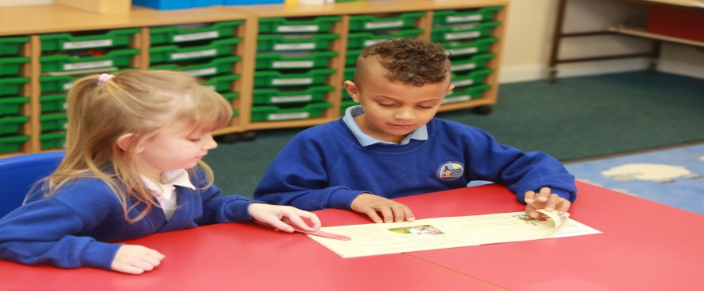

* Do a quick **sound warm-up** to remind ourselves of sounds that might be in the book.
* Quick **read tricky words**- so when they appear in the book, we are ready for them.
* Remind your child to sound out.
* Sound out words WITH them to help when needed.
* If they get stuck – give them a few seconds thinking time then tell then the sound, digraph. It is often the digraphs that they forget (ou, or, ai, etc).
* Use your **pointy finger** to follow the words as you read.
* Praise them, be encouraging: ‘good sounding out!’
* Note the punctuation and help when needed- don’t correct just help.
* Take turns to read, one sentence each or a page each.
* Commentate events and talk about what is happening.
* Re-read again and again to get ‘super-fast’ and fluent.
* When a child can read with expression- they are reading effortlessly.

**Top tips:**

* Make it fun! Reading should NOT be a chore! Read with them until they build their confidence and sound out more speedily.
* Re-read books over and over- it builds stamina, fluency and confidence.

**Comprehension – understanding**

* Model or think out loud to show understanding of events/ facts.
* Talk and say what is happening? Why?
* Can we predict the next event.
* Can we retell the story? What was out favourite part? Why?
* Can we say ‘why’ characters did certain things?

**Top tips:**

* Read just a beginning, then the next day retell and finish.
* 5 minutes at a time- little and often.
* Children need to practise sounding out to read (decodable- phonic) texts, but also need to have an adult read WITH them and TO them for enjoyment.

Answers:

|  |  |  |
| --- | --- | --- |
| **Reception phase 2** | **Year One phase 3** | **Year One Phase 5** |
| **pat**  **sat**  **mat**  **splat** | **s ai l**  **s n ai l**  **p ai n t**  **painting** | **day**  **say**  **play**  **spray**  **sprayed** |

Digraphs need a long sound button to show 2 letters but one sound. b **oa** t

Trigraphs need a longer sound button to show 3 letters but one sound. **n igh t**

Split digraphs are shown by a loop**, m a k e**

**Top tips:**

* Words with split digraphs make a long sound.
* The ‘e’ cannot be heard, because ‘When two vowels go walking the first does the talking.’
* We hear the first letter which is the letter name: a-e e-e i-e o-e u-e.

**Remember….have fun, learn together, little and often is best.**

**See our website for further support and resources.**

**Reading for Pleasure**

* **Love My Books** - <http://www.lovemybooks.co.uk/the-tin-forest> - a free resource to help parents and young children enjoy sharing books together. Includes carefully chosen books, resources and activities.
* **The World of David Walliams** - <https://www.worldofdavidwalliams.com/elevenses/> - daily story-time at 11am with David Williams who reads aloud one of his stories each day.
* **Storyline** - <https://www.storylineonline.net/> - this site features accomplished actors and actresses reading some of their favourite children’s books. Each story comes with a free activity guide and can be viewed on YouTube or SchoolTube.
* **Storynory** - <https://www.storynory.com/> - a collection of original, fairy-tale, and classic children’s audio stories.
* **National Literacy Trust** - [www.literacytrust.org.uk](http://www.literacytrust.org.uk) - this website contains a wealth of information and resources for use with pupils aimed at encouraging early communication skills and early reading skills. Free literacy resources - a selection of some brilliant literacy resources that you can access free of charge.
* **The Reading Realm** - <https://thereadingrealm.co.uk/> - hear a story and take part in some creative activities each day.
* **Children's books read online by Oliver Jeffers** - Facebook <https://m.facebook.com/oliverjeffersart/photos/a.391765256611/10156586435571612/?type=3>
* **Kids’ Poems and Stories with Michael Rosen** - free stories, poems, songs, and jokes - YouTube. Subscribe and only click on the poet/authors name. <https://www.youtube.com/user/artificedesign/videos>
* **Solomon Kingsnorth** - <https://www.researchify.co.uk/audiobooks.html> - free books in PDF, Word and audiobook format - Alice in Wonderland / Wind in the Willows / The Railway Children / The Jungle Book / Peter Pan / Black Beauty
* **Worldbook** - <https://worldbook.kitaboo.com/reader/worldbook/index.html#!/> - 3000 Ebooks and audiobooks - free for children of all ages.
* **Authorfy** - <https://authorfy.com/> - provides free masterclasses from famous writers.
* **BBC Bitesize** - <https://www.bbc.co.uk/bitesize/primary> - a well-used site with interactive games and activities for all subjects including primary English.
* **Books for Keeps** - <http://booksforkeeps.co.uk/> - on-line book magazine for children.
* **CLPE – Poetry Line** - <https://clpe.org.uk/poetryline> - has a free poetryline section, where children can discover 100s of poems.
* **The Kid Should See This -** <https://thekidshouldseethis.com> - wide range of educational videos that could be used as a stimulus for talk and writing.
* **Oxford Owl for Home -** <https://www.oxfordowl.co.uk/for-home/> - a wealth of activities for parents to do with their children.

**Vocabulary and Language Development**

Remember the importance of **talk**, your children will learn a huge amount from listening to you tell them jokes and funny stores and talk about the world around them so make the most of this precious time. Also, don’t forget that playing **board games** is a great way to help your children to increase their vocabularies, and therefore improve their reading levels. There are many excellent games which will subtly enforce the skills without them even knowing it! A board game is set up for competition and children focus on the idea of winning and completing the challenges and do not even realize they are also improving their vocabulary at the same time. This is a great way for you as parents to help your children to acquire a bigger vocabulary. Here are some good games you could play. You could also make up your own or use a good old favourite like the Tray Game (a list of objects with less common names e.g. covered with a cloth. Give them 3 minutes to memorise as many as they can and then take one away and see if they can guess what it is.

* **Scrabble**
* **Boggle**
* **Upwords**
* **Taboo**
* **Scattergories**
* **Balderdash**
* **Catchphrase**
* **Pictionary**
* **The Tray Game**
* **Guess who**
* **Who am I (post it not on forehead)**
* **I went to the shop and bought…..**
* **Charades**

**Other games**

* **The Word Wizard** – challenge your children to find two new words every day and use them in a sentence. See if they can trick you by making up words too and test if you can spot them.
* **Call My Bluff –** pick three unusual words and definitions and put them in a hat. Now add a made-up word and definition and challenge your children to guess which ones are true or false. With older children, challenge them to make up the new word and definition.
* **Word poem** – pick your favourite word and make a poem out of it, e.g. spaghetti or avalanche. There is a great **website** to support this which is on the National Literacy Trust website with the poet Simon Mole - <https://literacytrust.org.uk/resources/simon-mole-digital-poet-residence/>
* **Word Association Game –** think of a word and then take turns to think of other linked words**,** give a prize to the best word.
* **Mash-up words –** challenge your children to make up new compound words and give them meanings, be as silly as you like e.g. Hobbgobbler – a cross between a hobbit and a goblin.
* **Word searches/Hangman**

**Useful Websites**

* **The Game Gal** - <https://www.thegamegal.com/> - word lists and suggestions of word games to play as a family.
* [**Discovery Education**](http://puzzlemaker.discoveryeducation.com/) - <http://puzzlemaker.discoveryeducation.com/> - free tool to make your own word puzzles.
* **Word Games** - <https://www.games.co.uk/games/word> - a range of fun word games, daily word searches, crosswords and puzzle games.
* **Wordle -** <http://www.wordle.net/> - a toy for generating “word clouds” from text that you provide.
* **Knoword** - <https://playknoword.com>/ - a fast-paced word game that challenges your vocabulary, tests your typing skills, and stimulates your mind.
* **Brain Games** - <https://www.brain-games.co.uk/Word+Games> - play games like crosswords, hangman, word search and vocabulary games.
* **Twinkl** - <https://www.twinkl.co.uk/resources/ks2-english/ks2-words-and-vocabulary/ks2-words-and-vocabulary-activities-and-games> - fun activities to increase your child’s vocabulary and to learn about word origins
* **Puzz Grid** – <https://puzzgrid.com> - this is based on the game Only Connect, where people have to make connections between words - many of the words could potentially go in different groups, which makes it harder.

